READING

I. Read the following passage and answer the questions.

Once there lived a cap seller who sells caps in the market. One day he was passing through a forest to go to a village carrying a basket full of caps on his head. He felt tired, and fell asleep. After sometime, he woke up and he found his basket empty. He was worried, and saw some monkeys sitting on the tree wearing the caps. He made a plan to get his cap. He removed his cap and threw it on the ground. At once all the monkeys took off the caps they were wearing and threw them down. The cap seller collected quickly and went away.

Q1. What did the cap seller sell?

____________________________________________________________Q2. Where was he going to through the forest?

____________________________________________________________

Q3. What did he do on the way?

___________________________________________________________

Q4. Where were his caps?

____________________________________________________________

Q5. What did he find when he woke up?

___________________________________________________________

Q6. From the story pick out the past tense for:

(a) throw- _______ (b) feel- _________

Q7. From the story pick out opposite for:

(a) full ___________ (b) standing _______________

From the story pick out the rhyming word for:

Q8. where - _________ , _____________

Q9. pound - ____________ , _____________

Q10. One who sells cap is known as _______________.

II.Read the following passage and answer the questions.

Mother, your baby is silly! She is so very childish. She does not know the difference between the lights in the streets and the bright stars. When we play with pebbles, she thinks they are real food. She putsthem into her mouth. When I open a book she tears the pages and roars with joy.

1. Who is silly?

Ans __________________________________________________

1. She is so very ____________________.(childish/playful)
2. Does she know the difference between the stars and lights in the streets?

Ans _______________________________________________________

1. What does the child play with?

Ans_____________________________________________________________

1. What does she think about the pebbles?

Ans __________________________________________________________

6.The little girl puts the pebbles__________(into/onto) her mouth.

7.What does the little girl tear?

Ans _________________________________________________________

8.Write the ***plural*** forms.

House_____________________. page­­­­­­­­­­­­­­­­­­­­­­­­­­­­­­­­­­­­­­­­­­­­­___________________________

*9.*Find out the ***opposite*** of

*intelligent****__________________________***

10.Find out the opposite of

***close*** ___________________________

*WRITING*

Answer the following questions:

Q 1. Why is the camel called “the ship of the desert”?

________________________________________________________________________________________________________________________

Q 2. What is the vegetable man selling ?

____________________________________________________________

______________________________________________________

Q 3. What are the precious loads that trains carry ?

____________________________________________________________

______________________________________________________

Q 4. What did the man say to Meena in “He is my brother” story?

____________________________________________________________

______________________________________________________ Q 5. Why do the child go with the puppy in “Puppy and I poem”? ___________________________________________________________________________________________________________

GRAMMAR

1. Give the opposite gender for:

(a) sir- ______ (b) father - _________

2.Write the plural form for:

(a) leaf-__________________ (b) house - __________________

3. Fill in the blanks with the right word:

group, bunch, herd.

1. A _______________ of people gathered to see the accident.
2. A ______________ of cattle blocked the busy road.

4. Write the full form of the following:

(a) don’t- ______________ (b) Can’t- _________________

6 ***.* Rearrange** the jumbled words to get sentences.

c. play / on / Don’t / the / road.

___________________________________________________________________

d. Let’s / on / the / get / train.

_____________________________________________________________

(B) Fill in the blanks with ‘can’ or ‘cannot’:

1. I can lift this box. But my sister ____________.
2. A rabbit ____________ run fast but a tortoise_____________.

7. Name the person-

(a) who cures your illness - _____________________

(b) who delivers your letters - ________________________

Creative Writing



1. Write five sentences on ***camel.***

______________________________________________________________________________________________________________________________________________________________________________________________________________________________________________________________________________________________________________

1. Describe the picture:

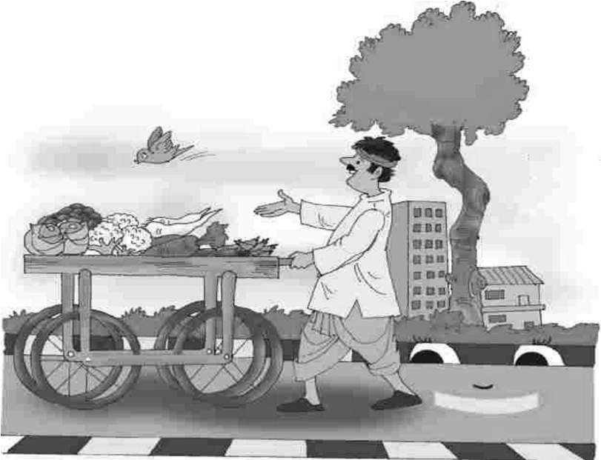

________________________________________________________________________________________________________________________________________________________________________________________________________________________________________________________________________________________________________________________________________________________________________________________________________________________

SPELLING

***Supply the missing letters.***

1. M___r___ing 6. A____wa_____s
2. Gi____nt 7. ____owl
3. N___u____hty 8. P____p____y
4. L___ad 9.N___wsp___pe____
5. D___ nk____y 10. Fr___ ___ght

HANDWRITING

43. Reproduce the following passage legibly:

Knowledge is what all that a person knows. Without knowledge, it is not possible to raise high in life. A doctor is called knowledgeable if he knows how to treat a patient effectively. A wise or knowledgeable man is truly powerful in all respects.

_______________________________________________________________________________________________________________________________________________________________________________________________________________________________________________________________________________________________________________________________________________________________________________________________________________________________________________________________________________________________________________________________________________________________________________